Computer Networks Lab

Quiz

Name: Ahmed Kasteer

Roll Number: 20F-0336

Section: 5C

**Question 1:**

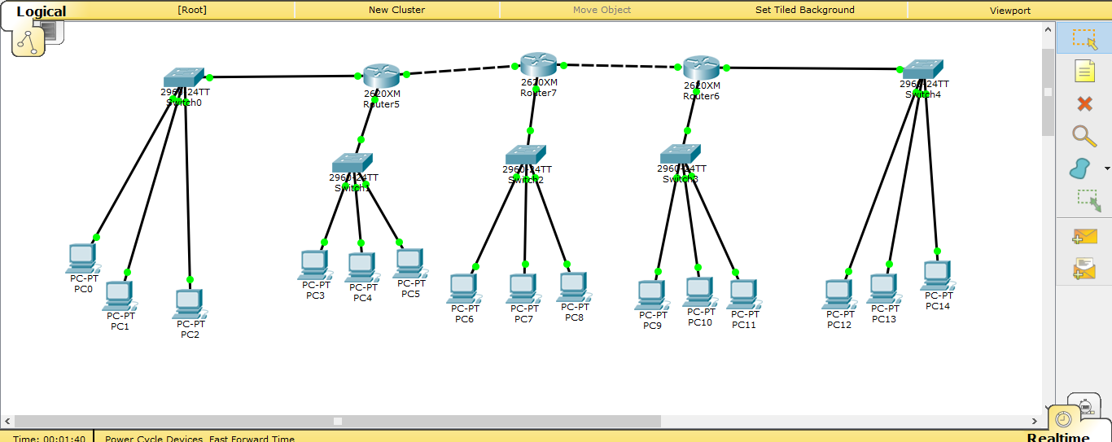

**Router 5:**

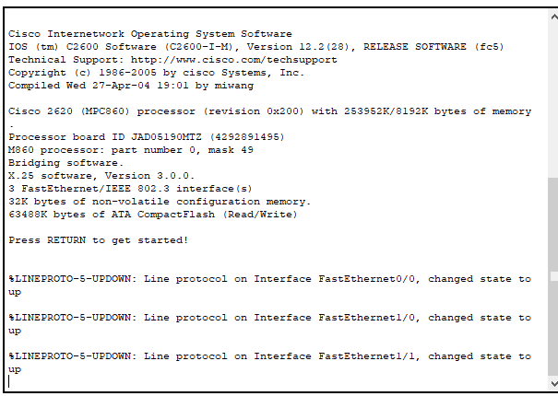

**Router 7:**

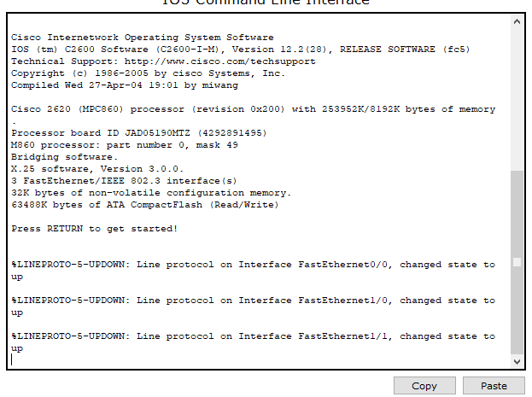

**Router 6:**



